Project Description

1.1 Project
Elevate Oil Level Sensor Test Tank

1.2 Description
The Elevate Oil Level Sensor Test Tank (Elevate OLS-TT) uses LabVIEW to Automate the ATP process and add AEPS Testing functionality.

1.3 Revision History
Date | Comment | Author
6-10-2024 | Initial Release | R. Ales Consulting

Contents
Section 1 - Project Description
1.1 Project
1.2 Description
1.3 Revision History
Section 2 - Overview
2.1 Purpose
2.2 Scope
2.3 Requirements
2.3.1 Estimates
2.3.2 Traceability Matrix
Section 3 - System Architecture
Section 4 - Data Dictionary
Section 5 - Software Domain Design
5.1 Software Application Domain Chart
5.2 Software Application Domain
5.2.1 Domain X
5.2.1.1 Component Y of Domain X
5.2.1.1.1 Task Z of Component Y1 of Domain X
Section 6 – Data Design
6.1 Persistent/Static Data
6.1.1 Dataset
6.1.2 Static Data
6.1.3 Persisted data
6.2 Transient/Dynamic Data
6.3 External Interface Data
6.4 Transformation of Data
Section 7 - User Interface Design
7.1 User Interface Design Overview
7.2 User Interface Navigation Flow
7.3 Use Cases / User Function Description
Section 8 - Other Interfaces
8.1 Interface X
Section 9 - Extra Design Features / Outstanding Issues
Section 10 – References
Section 11 – Glossary

….

Configuration Management
Configuration Management practice of tracking and controlling changes to a system.

LabVIEW Development System

LabVIEW Run time installation and application deployment.

Software Versioning
Version indicator consisting of two values the first is letter representing the Major revision and a number representing a minor revision.

- Major revision indicates the following applicability of the code:
  - Where E (Engineering) versions are for development evaluation only.
  - Where Q (Quality) versions are for interdepartmental evaluation but not for production, often referred to as Beta software.
  - Where letters A-D, F-P represent code has been qualified and released for production, the first release starts with A then incremented with a major release defined as not 100% backwards compatible (form, fit and function) with the prior release.
- Minor revision are two numbers, incremented with any change that remains 100% backwards compatible, (not materially affecting form, fit or function.)

Git Branching Strategy
A branching strategy is a strategy that software development teams adopt for writing, merging and deploying code with the help of a version control system like Git. Since this project is likely to have a single developer, the simpler, streamlined branching “Github Flow” strategy shall be used.
- Main Branch The primary branch of a Git repository where the most recent stable, production-ready code resides.
- Feature Branch is a development branch, created to work on a specific feature or task isolated from the main branch. Feature branch code distributed for deployment versioned as the Next release version prefixed with a Q. For example, if the Main Brance is version A02, then the Feature branch implementing a minor change shall be versioned QA03.
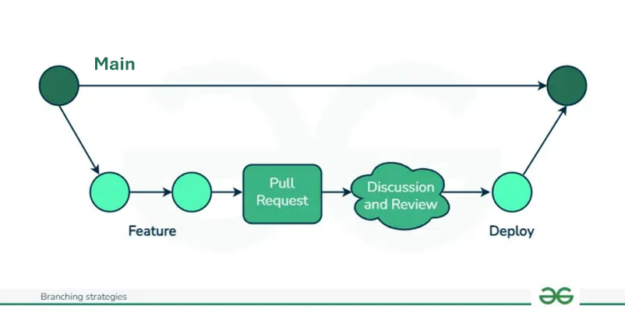
- Merge: The process of combining changes from one branch into another. In the case of using LabView, the simplest merge would be to simply replace the Main branch with the Feature branch when released.

Release Checklist and Procedure

